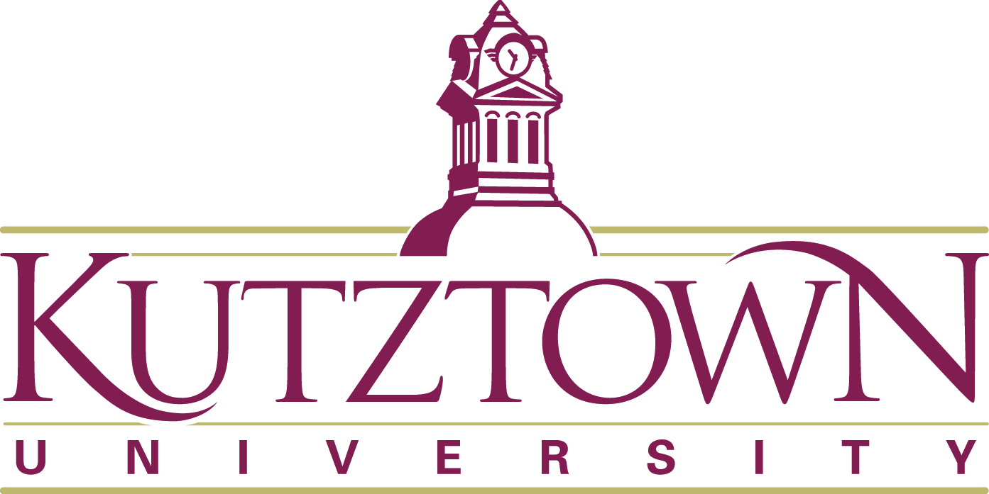

Dear Educator, Librarian, and Lover of Literature,
This is our Twenty-sixth Year Celebrating Children’s Literature. Our full-day conference for teachers and librarians is Saturday, April 13, 2024. Act 48 credits are offered. We have amazing, award-winning presenters: Beth Ferry John Steven Gurney, Jennifer A. Nielsen, and Carole Boston-Weatherford. Beth Ferry is an ILA Children’s Choice Award winning author. John Steven Gurney is best known for his A-Z Mysteries and Fuzzy Baseball. Jennifer Nielsen’s historical fiction is the recipient of a Whitney Awards for Best Middle Grade Book. Carole Boston-Weatherford is the winner of a John Newbery Honor Medal and the Coretta Scott King Award. The following core standards will be aligned to presentations: CC.1.3. (PK-5).B - Reading Literature – Key Ideas and Details – Text Analysis and CCSS.ELA-LITERACY.RI.5.3 –– Historical Fictional Texts, CC1.4.3 P (PK-5) – Content – Writing Process and Word Play.
We have decided to continue to host virtual presentations for schools as we did last year. They were a huge success. No buses are necessary to bring students to campus and allows us bring renowned authors/illustrators to children in the classroom. It also allows us to reach many more students and any school that wishes to attend. The presentations will be held Wednesday, April 10, 2024. Cost is $20.00 per class. A registration form for school presentations is included.
Grades 1-3 10:00 AM -11:00 AM with Beth Ferry (Zoom webinar)
Grades 5-8 1:00 PM-2:00 PM with Jennifer A. Nielsen (Zoom webinar)
Please share this information with interested parties in your school. We are always looking for new individuals to participate in our conference. Check out our website at www.kuchildrensliterature.weebly.com as well as Facebook. For additional information contact Jamie at 610-683-4627 or email ChildLitConfKU@gmail.com
Sincerely,
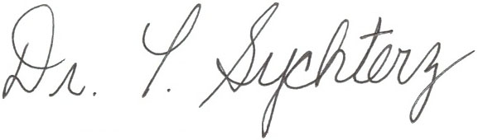
Terre Sychterz Chair, KU Children’s Literature Conference

